**UNIVERSITY OF GREENWICH**  
COMP1649 – Human Computer Interaction and Design

Coursework

|  |  |
| --- | --- |
| Student name | Chau Tran Quoc Tuan |
| ID number (00xxxxxxx) | 001353549 |
| Lecturer/Tutor name | Phuong Ha Dang Bui |
| Student submission date | November 24, 2023 |
| Word Count | 4790 words |

Table of Contents

1 Introduction 1

2 Background literature 1

2.1 HCI Research 1

**2.1.1 Background** 1

**2.1.2 Related Products** 1

**2.1.3 Literature Review and Requirements Elicited** 1

2.2 HCI Theory 2

**2.2.1** **Interaction design principles and interaction design patterns** 2

2.2.2 **Investigation in cognitive psychology** 2

**2.2.3** **Interaction design framework** 3

**2.2.4** **Interaction design theory** 3

**2.2.5** **Types of interaction and modes of interaction** 4

3 Design Process 4

3.1 Conceptual Design 4

**3.1.1** **Problem statement and design solutions** 4

**3.1.2** **User requirement** 1

**3.2** **Design principles** 2

4 Prototype 2

4.1 **Low-fidelity prototype** 2

**4.2** **Mid-fidelity prototype** 4

**4.2.1** **Register and Login Page** 4

**4.2.2** **Hom page** 7

**4.2.3** **Tracking page** 8

**4.2.4** **Taking photos and videos** 9

**4.2.5** **Tracking Details** 10

**4.2.6** **Gallery page** 13

**4.2.7** **Setting page** 14

**4.3** **Describe the physical prototype.** 18

5 Research Study 1

6 Conclusion 3

7. References 1

8. Appendices 1

**8.1** **Appendices 1** 1

**8.2** **Appendices 2** 2

**Analysis for Hypothesis 1:** 2

**Analysis for Hypothesis 2:** 4

Table of Figures

Figure 1. Hierarchical model 5

Figure 2. Conceptual model 1

Figure 3. Login, Register and Verify phone number. 3

Figure 4. Home, Gallery, and Tracking 3

Figure 5. Setting and Profile 4

Figure 6. Login 5

Figure 7. Register 6

Figure 8. Loading Login 7

Figure 9. Home Page 8

Figure 10. Tracking 9

Figure 11. Tracking 10

Figure 12. Tracking Details 11

Figure 13. Edit Track 11

Figure 14. Search Track 12

Figure 15. Delete Track 13

Figure 16. Gallery Page 14

Figure 17. Setting Page 15

Figure 18. Change unit of measure 15

Figure 19. Dark Mode 16

Figure 20. Profile 17

Figure 21. Edit Profile 17

Figure 22. Physical Prototype 18

Figure 23. Participants 2

Figure 24. Questionnaire for Hypothesis 1 1

Figure 25. Questionnaire for Hypothesis 2 2

Figure 26. Question 1 3

Figure 27. Question 2 3

Figure 28. Question 3 4

Figure 29. Question 4 4

Figure 30. Question 1 5

Figure 31. Question 2 5

Figure 32. Question 3 6

Figure 33. Question 4 6

# Introduction

This report documents the process and results of designing an interactive prototype for a mobile application for snorkelers and scuba divers. The brief was to create a mobile application that would allow users to take and view photos/videos underwater, while also tracking dive details such as depth and dive time. The scope is limited to these two core functions of vehicle collection and dive logging.

The report outlines the project's background, target users, competitive analysis, design process, final concept, and interactive prototype. It describes the process of conducting user research, personal development, ideation, and prototyping. The app's main user interfaces, interactions, and journeys are marked with annotations explaining why.

# Background literature

## HCI Research

### **2.1.1 Background**

Mobile applications for diving and snorkelling have grown in popularity in recent years. These apps aim to enhance the underwater experience by providing useful tools for planning, logging, and sharing diving activities. Key capabilities of many existing apps include dive logging, underwater photo/video capture, dive site maps, and social sharing.

### **2.1.2 Related Products**

**Deepblu** is a popular diving app that enables logging of dive details including depth, time, location, and underwater photos/videos. Users can view dynamic dive profiles and statistics. Deepblu has a social component for sharing dive data.

**DiveMate** allows divers to log dives, attach media, and view data visualizations. Key features include monitoring tank pressure, tracking locations, and planning repetitive dives. Data can be exported for backup.

**Diveboard** aggregates user submitted dive logs, photos, and videos. Users can browse entries by location, contribute content, and plan future dives. It facilitates finding and sharing diving locations.

### **2.1.3 Literature Review and Requirements Elicited**

The UX design for a diving app needs to be considered and considered. According to (Viren Bajaj, 2019) monitoring oxygen tanks is an important safety factor when diving because running out of oxygen before surfacing can be life-threatening. Additionally, ambient light conditions underwater interfere with divers' visual perception.

This demonstrates the need to design a system for use in underwater diving conditions, estimating the amount of remaining air. The goal was to verify the system could warn divers before running out of air so they could safely surface. Use intuitive, easily recognizable icons and large buttons to minimize cognitive workload. Additionally, features such as dive logging, timing, location tracking, photo and video capture, and gallery enhance the user experience.

## HCI Theory

### **Interaction design principles and interaction design patterns**

* **Definition of Interaction Design**

According to (Talmon, 2003) Interaction Design is a crucial process that enhances user interactions with products, services, or digital systems. It involves understanding user interactions and creating efficient, interesting interfaces. The effectiveness of a software is influenced by the user's context, culture, knowledge, and resources, making interaction design a new discipline that focuses on creating a pleasant and engaging user experience.

* **Interaction design principles**

According to (Norman, 1988) key interaction design principles including visibility, feedback, constraints, mappings, consistency, and affordances. These principles advocate designing interfaces and objects that are understandable and intuitive for users by leveraging knowledge of human psychology and capabilities.

* **Interaction design patterns**

According to (Alexander, 1977) in computer science and architecture, a design pattern is a formal method of recording a solution to a design challenge in a certain area of expertise. A pattern language is an organized set of design patterns related to a certain area.

* **Interaction design principles applied to this coursework.**

This design will apply all six principles, because they are standard for user ease of use and a good experience.

### **Investigation in cognitive psychology**

According to (Jacko, 2012) cognition refers to the range of mental processes that allow people to perceive, learn, remember, problem-solve, and make decisions about the world around them. Different cognitive functions have different strengths and limitations. In interaction design, understanding how cognition works is crucial because it determines how people think about and use technologies. Interaction designers can leverage knowledge of cognitive psychology to create interfaces suited to human capabilities.

How aspects of cognitive psychology affect interaction design:

* **Attention -** Selective attention and divided attention affects how users focus on interfaces.
* **Perception -** Gestalt laws of perceptual organization shape how users interpret visual interfaces.
* **Memory -** Working memory limits affect the amount of information users can process.
* **Recognition -** Recognition involves matching new information to patterns in memory. Designers can leverage users' prior knowledge through familiar symbols and conventions.
* **Cognitive psychology principles applied to this coursework.**

The main cognitive principles involved in diving computer interfaces are attention, memory, recognition, and perception. The display needs to be designed with high visibility and warnings to draw divers' attention to important safety information. Only the most important data are shown to explain the limitations of working memory. Interface elements should be organized to optimize underwater perception and allow for rapid interpretation.

### **Interaction design framework**

**User-centered design:**

This approach puts the preferences, capabilities, and restrictions of end users at the forefront when designing and developing products. It emphasizes conducting user research, testing ideas with users, and refining concepts based on user feedback (Norman, 1986).

**Goal-directed design:**

This process first identifies what users want to accomplish and what they need to do so. It then makes design choices based on satisfying those goals and needs. It focuses heavily on early-stage user research and mapping user workflows (Cooper, 2007).

**Activity-centered design:**

This philosophy highlights designing for the context and situation in which a product will be used, not just the individual users or features. It considers how social, cultural, and practical factors shape activities that products support (Gay, 2004).

**Participatory design:**

This approach actively involves all stakeholders throughout the design process to ensure the product is usable and meets their requirements. It typically uses cooperative workshops with users to take advantage of their knowledge (Schuler, 1993).

### **Interaction design theory**

* **Conceptual Model:**

A conceptual model is an abstract diagram or diagram that describes how a user should understand how a product or user interface works. As Johnson and Henderson explain, "A conceptual model is a high-level description of how a system is organized and operates" (Johnson, 2002). Conceptual models allow users to form appropriate mental models of a system to enable task completion and guide interaction.

* **Metaphors:**

Metaphor in interaction design involves using images or language from another field to help users understand how a product works. As Burke explains, "A metaphor is a device for seeing something in terms of something else. It brings out the thisness of a that, or the thatness of a this" (Burke, 1945). For example, the "Delete" button in the app has a trash icon to indicate the action of discarding or destroying.

* **Prototypes:**

A prototype is a test version of a product or user interface. They are created to test and implement design ideas, gather input from users, and identify design issues before implementing the final product. As Houde and Hill explain, “Prototypes provide a means to test design problems and evaluate solutions” (Houde, 1997).

There are three main types of templates:

* **Low-fidelity prototypes:** These are rudimentary prototypes, often created with paper, pen, or simple software tools. They focus on basic design ideas without too much emphasis on details or the actual look.
* **Mid-fidelity prototypes:** These are mid-fidelity prototypes, usually created using graphics software tools and are closer simulations of the final product.
* **High-fidelity prototypes:** These are highly detailed prototypes, often near-complete simulations of the final product, including user interface, interactions, and other elements. specific design elements.
* **The types of prototypes applied to this coursework.**

Early drawings and UI mock-ups are produced with the aid of low-fidelity and mid-fidelity prototypes for a diving application project. Mid-fidelity prototypes can help in assessing certain user experiences and identifying interface strengths and flaws.

### **Types of interaction and modes of interaction**

* **The main types of interaction:**
* **Instructing:** To use the system, users must provide commands and instructions.
* **Conversing:** A conversational interface is used for the user and system's interaction, which entails a constant flow of communication.
* **Manipulating:** Through manipulation, the user engages with virtual things on the interface directly
* **Exploring:** Open-ended interaction to browse and discover content. Move around data and images as they are being explored.
* **The interaction types applied to this coursework.**

The interface would primarily utilize instructing for divers to set parameters and receive alerts and exploring to navigate display information.

* **The modes of interaction:**
* **Touch:** Interact using touch or touching the screen or touch surface.
* **Voice:** Voice interaction, where the user uses voice commands to interact with the system or device.
* **The interaction modes applied to this coursework.**

As divers can easily interact with the device with their fingertips underwater, the "Touch Interaction Mode" applied to the diving application produces a user-friendly and simple to use interface. This enables them to readily retrieve important information and carry out critical duties in the underwater environment.

# Design Process

## Conceptual Design

### **Problem statement and design solutions**

**Problem:** We were faced with the challenge of creating a new interactive product, designed specifically for snorkelers and amateur divers, with a few important features included. underwater uses such as taking photos and videos, and the ability to track details of the dive.

**Interface Design Solutions (UI Design Solutions):**

* **User-Friendly Underwater Interface:** Create a user-friendly underwater interface, with large, recognizable icons and controls that are easy to use underwater. Use contrasting colours and images to help users easily identify interface elements underwater.
* **Underwater Photo and Video Capture Function:** Integrate underwater photography and video recording features directly into the interface, with simple options and easy operations so users can document their experiences.
* **Show Diving Activity Details:** Displays diving activity details in a clear and easy-to-read manner. Use charts, graphs, and digitized information to show current depth, time spent afloat, amount of air remaining in the tank, and duration of the dive.

#### **Hierarchical model**

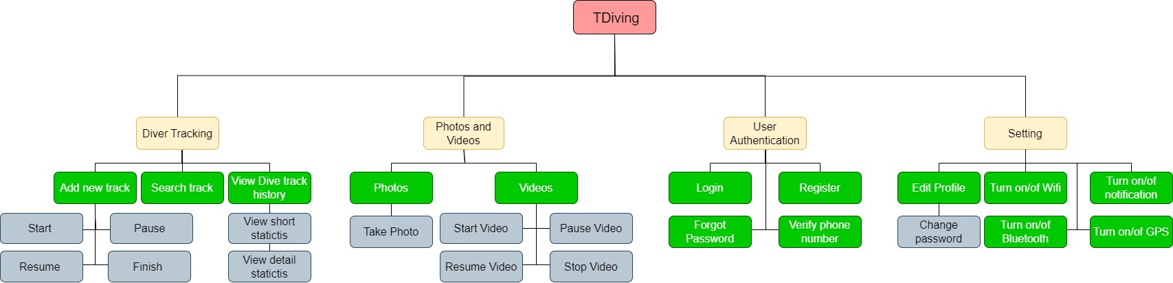

Figure . Hierarchical model

The hierarchy model consists of four main sections: Diver Tracking, Photos/Videos, User Authentication, and Settings.

Diver Tracking allows adding and viewing dive tracks, with related sub-options for new track creation, searching tracks, and history. Photos/Videos provides functionality for capturing and accessing diving images and videos.

User Authentication covers account management like login, registration, password reset and verify phone number. Settings includes both system settings like Wi-Fi/Bluetooth and user preferences like notifications and interface personalization. Profiles are also edited in this section.

This hierarchy provides an organized information structure for the app, flowing from general functions to more detailed options. It helps define the overall user experience blueprint and site map navigating between these levels. The model serves as a framework for structuring features and content within the diving application.

#### **Conceptual model**

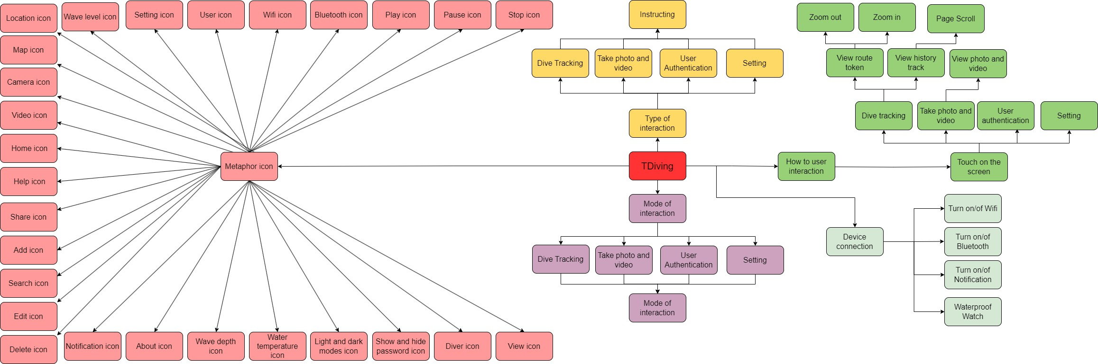

Figure . Conceptual model

The conceptual model shows different types of user interactions like instructing, conversing, manipulating etc. It also covers interaction mode touch. The Metaphor Icon section appears to represent the visual icons and symbols used in the diving application's interface. The metaphors used aim to leverage real-world diving concepts and universal symbols that users can intuitively understand on the device interface. This enhances usability as the icons tap into existing user knowledge.

|  |  |  |
| --- | --- | --- |
| **No.** | **Number** | **Meaning** |
|  | User icon | Represents user |
|  | Wi-Fi icon | Indicates wireless connectivity |
|  | Bluetooth icon | Shows Bluetooth is on |
|  | Play icon | Start diving track |
|  | Pause icon | Pause diving track |
|  | Stop icon | Finish diving track |
|  | Map icon | View map during dive |
|  | Camera icon | Take photos during dive |
|  | Video icon | Record videos during dive |
|  | Home icon | App home screen |
|  | Help icon | Get help/info |
|  | Share icon | Share content with others |
|  | Setting icon | Adjust app settings |
|  | Water temperature icon | View water temperature |
|  | Wave depth icon | See depth of waves/water |

### **User requirement**

After conducting interaction design research, I recommend two main modules for project:

* **Take photos and record videos underwater:**
* **Photo and video quality:** The product can capture high-quality underwater photos and videos to record diving experiences clearly and realistically.
* **Easy to use underwater:** The product needs to have an easy-to-use underwater interface, including appropriate controls or interactions so users can easily take photos and videos underwater without difficulty.
* **Data storage and management:** The product needs to provide the ability to store and manage photos and videos recorded from diving activities. Users want to be able to access and review this data once back on land or on a boat.
* **Track and view diving activity details:**
* **Track diving details:** The product should provide detailed information about the user's diving activities, including current depth, surface time, remaining air in the tank, duration of the dive, and other information. others related.
* **History and notes:** The product needs to record a history of previous dives so users can track and review their activities. They also need to be able to add notes or additional information to each dive.
* **Warnings and security:** The product needs to be able to warn the user of dangerous situations during diving, for example, a sudden increase in depth or a dangerous level of residual gas. At the same time, user data security is also very important to ensure privacy and safety.

## **Design principles**

**- Visibility:** The design should make all required information and controls visible to the user. Key elements should be conspicuous and easy to locate.

**- Feedback:** The design should provide clear, informative feedback about user actions and system state. Users should understand the effects of their inputs.

**- Constraints:** The design should exploit physical, logical, semantic, and cultural constraints to guide proper usage. Constraints can limit incorrect affordances.

**- Mappings:** The design should map controls and information in an intuitive way that matches expectations and needs. Mappings leverage spatial relationships, cultural standards, etc.

**- Consistency:** The design should be consistent in controls, terminology, icons, colors, fonts, etc. A consistent interface is easier to learn and use.

**- Affordances:** The design should suggest and communicate proper usage and interactions through its own properties and qualities. Affordances provide strong clues about operations.

Overall, these principles are standard for the designs. Therefore, to apply these principles as follows:

**- Visibility:**  The design will clear interface, display color and size to ensure the main functions and information are highlighted.

**- Feedback:** The design will provide immediate feedback such as error messages or successful update notifications. Notifications or status updates help users know where they are and what status they are in.

**- Constraints:** The design will clearly identify the available actions and limit them to avoid confusion. For example, use "Confirm" and "Cancel" buttons instead of just an ambiguous "OK" button.

**- Mappings:** The design will use real-world metaphors for logically corresponding elements and functions.

**- Consistency:** The design will be consistent in color, font, and icon size for the interface.

**- Affordances:** The design will use text field or buttons. So that users can easily recognize input or click events.

# Prototype

## **Low-fidelity prototype**

Figure . Login, Register and Verify phone number.

Figure . Home, Gallery, and Tracking

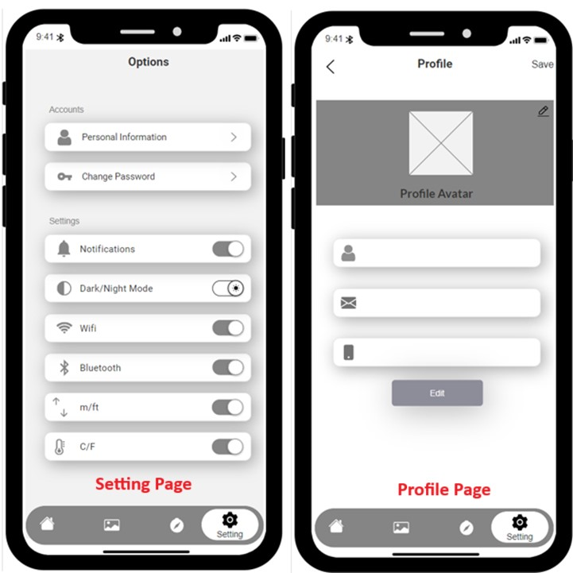

Figure . Setting and Profile

## **Mid-fidelity prototype**

### **Register and Login Page**

Figure . Login

When the application starts, the user will be taken to the Login interface (Figure 6 A). Here the design has applied the **Feedback** principle by providing immediate feedback when the user does not type but presses the Login button (Figure 6 B).

Figure . Register

If the user does not have an account, below the Login button there will be a section to go to the Register interface (Figure 7 A). Similar to Login, Register will also provide feedback to the user (Figure 7 B). Besides, Login and Register also use text fields and buttons to help users easily identify. This applied the **Affordances** principle. For each text field, there is hint text to guide the user on what content to enter, using **Instructions** of Interaction.

Figure . Loading Login

Upon successful login, the design will respond to a loading page (Figure 8 A) and a successful login notification (Figure 8 B).

### **Home page**

Figure . Home Page

Next, the user will be redirected to the home page interface (Figure 9 A). Photos, videos, and tracks list will appear here. When the user clicks to view the image, the image will enlarge (Figure 9 B). Besides, the navbar below helps users easily switch pages. **Memory** of cognitive psychology is also applied to the navbar, the navbar appearing on pages helps users remember that the navbar is used to turn pages. The design is consistent in the color of the logo and navbar background, font, and icon size. This applied the principle of **Consistency**.

### **Tracking page**

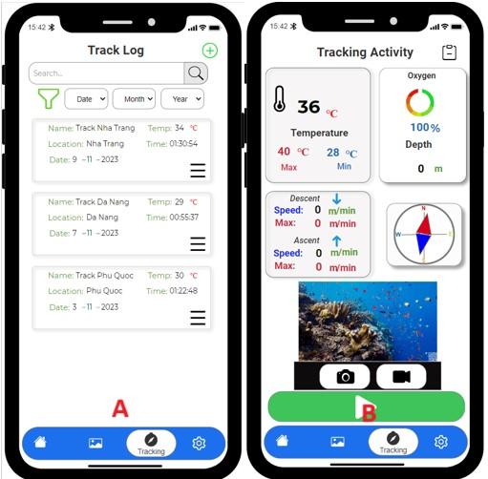

Figure . Tracking

When touching on list tracks in home page, it takes the user to the track log page (Figure 10 A). To add a new track, simply tap the add icon in the upper right corner, which will lead users to the Tracking page. Mostly, users need to touch to use, because the mode of interaction used for the design is “**Touch**”. Besides, the design also applies **Mapping** principles by using real-world metaphors such as icons in the navbar and camera icons.

### **Taking photos and videos**

Figure . Tracking

When the start button is pressed, track information will be displayed (Figure 11 A). While tracking, users can take photos (Figure 11 B) or record videos (Figure 11 C).

### **Tracking Details**

Figure . Tracking Details

When the track ends, the track will be saved to the track log page (Figure 12 A). Here users can view track details on the track details page (Figure 12 B) by touching the icon on each track.

Figure . Edit Track

On the Track Details page, users can edit the track name (Figure 13 A). After editing and pressing the Update button, the track name will be changed (Figure 13 B).

Figure . Search Track

Here, the design has applied **Recognition** of cognitive psychology by placing the search bar next to it and the date selection drop-down bars to help users easily identify to search the tracks (Figure 14 A&B). Users can select tracks by touching and holding the track (Figure 14 C).

Figure . Delete Track

Here the design has applied the **Constraints** principle to ask the user to confirm track deletion, with the prominent button and background also applying **Attention** of cognitive psychology (Figure 15 A). After the user confirms, the track will be deleted (Figure 15 B).

### **Gallery page**

Figure . Gallery Page

The library page will display photos (Figure 16 A) and videos (Figure 16 B) of Tracks including track information.

### **Setting page**

Figure . Setting Page

With a clear layout design and prominent switches, this is the result of applying the principles of **Visibility** and **Perception** of cognitive psychology (Figure 17 A).

Figure . Change unit of measure

When the measurement units in the settings are set (Figure 17 B), the tracking will also change (Figure 18).

Figure . Dark Mode

Dark mode and Light mode can also be changed if the user turns the switch on or off (Figure 19).

Figure . Profile

On the Profile page, users will be able to edit information (Figure 20 A) and change their avatar (Figure 20 B).

Figure . Edit Profile

When pressing the Edit button, the design will allow users to edit information (Figure 21 A). After making changes and pressing the Save button, the message will be displayed (Figure 21 B).

## **Describe the physical prototype.**

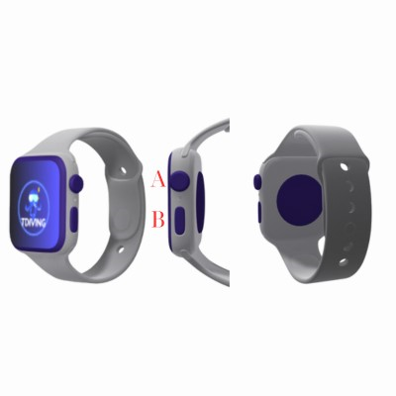

Figure . Physical Prototype

The physical prototype is designed as a waterproof watch, with 2 buttons A and B (Figure 22). Button A is used for tracking with 1 click, press, and hold to stop tracking. Button B is used to take photos with 1 click and record video with 2 clicks.

# Research Study

**Hypothesis 1:** The prototype interface will allow divers to access key information and execute functions more easily underwater compared to not using the interface.

**Hypothesis 2:** The use of real-world metaphors in the prototype interface will lead to higher intuitive understanding and usability ratings compared to not using metaphorical icons.

|  |  |
| --- | --- |
| **Hypothesis 1** | **Questions** |
| 1 | How do you rate the prototype of the T Diving application? |
| 2 | Do you regard the prototype of the T Diving application as simple to use and engage with? |
| 3 | Do you feel the prototype has positively influenced your diving experience? |
| 4 | Do you feel the prototype has positively influenced your diving experience? |
| **Hypothesis 2** | **Questions** |
| 1 | Do you find the meaning of real-world metaphors used in the T Diving application simple to understand? |
| 2 | How do you rate real-world metaphors that have enhanced your app's usability? |
| 3 | Do you feel that the real-world metaphors are completely reasonable? |
| 4 | Do you misunderstand real-world metaphors with different meanings when used? |

The questionnaire is presented in Appendices 1

**Participants and Methodology:**

For this study, 10 divers were recruited from diving community groups on social media. Of these, 70% of the participants are male and 30% are female, with ages ranging from 18 to 40. Their diving experience ranges from 1 to more than 4 years.

Participants will have access to a consent form stating the purpose of the study and ensuring confidentiality. After a brief introduction to the prototype, participants will be asked to provide feedback via a quantitative survey.

Figure . Participants

**- The conclusion proves the hypothesis**

Data analysis of hypotheses 1 and 2 is shown in appendices 2.

**Hypothesis 1:**

The survey results support the hypothesis that the prototype interface of the T Diving app was positively received by users. Users felt the prototype met their expectations in providing relevant diving information, suggesting room for improvement, overall consistent with the hypothesis, indicating a generally favourable reception of the usability and impact of the prototype on the diving experience.

**Hypothesis 2:**

The survey results strongly support the hypothesis regarding the use of real-world metaphors in the T Diving app. The survey results collectively support the hypothesis that the integration of real-world metaphors positively contributes to intuitive understanding and usability ratings in the T Diving app.

# Conclusion

The project undertook the design of an advanced diving application, focusing on optimization for underwater conditions and meeting the growing needs of recreational diving participants. Initial prototyping demonstrated that prioritizing the display of gas and location data based on psychometric principles increased the usability of the application. Adopt real-world and interactive modes that have been designed to suit specific diving needs, rather than simply reusing existing equipment.

While the project has shown promise, lab tests have shown that improvements in personalization, motivation, and a more robust structure are needed. There are limitations to the customization and size of the app, as well as issues related to durability and safety in water environments.

The personalization aspect needs to be improved so that users can customize the app according to their individual needs. At the same time, creating dynamics and improving material structure will help increase application flexibility and safety in diving conditions.

Development of a higher quality prototype version should be undertaken, focusing on improvements identified from previous feedback and testing. Further research into sensor technologies and materials will also help improve application flexibility and usability. At the same time, increased interaction and more hands-on testing in real diving conditions are also important steps for better application development.

# References

Alexander, C., 1977. *A Pattern Language: Towns, Buildings, Construction.* s.l.:Oxford university press.

Burke, K., 1945. *A Grammar of Motives.* New York: Prentice Hall.

Cooper, A. R. R. C. D., 2007. *About face 3: the essentials of interaction design.* Indianapolis, IN: Wiley Pub.

Gay, G. &. H. H., 2004. *Activity-Centered Design: An Ecological Approach to Designing Smart Tools and Usable Systems.* Cambridge, MA: MIT Press.

Houde, S. a. H. C., 1997. What do Prototypes Prototype?. In: *Handbook of Human-Computer Interaction (Second Edition).* Amsterdam: Elsevier Science B. V., p. 369.

Jacko, J., 2012. *Human computer interaction handbook: Fundamentals, evolving technologies, and emerging applications..* s.l.:s.n.

Johnson, J. a. H. A., 2002. *Conceptual Models: Core to Good Design.* San Francisco, CA: Morgan Kaufmann.

Norman, D. A. &. D. S. W., 1986. *User Centered System Design.* Hillsdale, NJ: Lawrence Erlbaum Associates.

Norman, D. A., 1988. *The Design of Everyday Things.* s.l.:Basic books.

Schuler, D. &. N. A., 1993. *Participatory design: Principles and practices.* Hillsdale, NJ: Lawrence Erlbaum Associates.

Talmon, D., 2003. International Journal of Medical Informatics. In: *Interaction design theory.* s.l.:Elsevier Ireland Ltd., pp. 205-222.

Viren Bajaj, K. E. N. F. A. P., 2019. Verifiably safe SCUBA diving using commodity sensors: work-in-progress. *Association for Computing Machinery,* pp. 1-2.

# Appendices

## **Appendices 1**

**Hypothesis 1:** The prototype interface will allow divers to access key information and execute functions more easily underwater compared to not using the interface.

Figure . Questionnaire for Hypothesis 1

**Hypothesis 2:** The use of real-world metaphors in the prototype interface will lead to higher intuitive understanding and usability ratings compared to not using metaphorical icons.

Figure . Questionnaire for Hypothesis 2

## **Appendices 2**

### **Analysis for Hypothesis 1:**

**Question 1:**

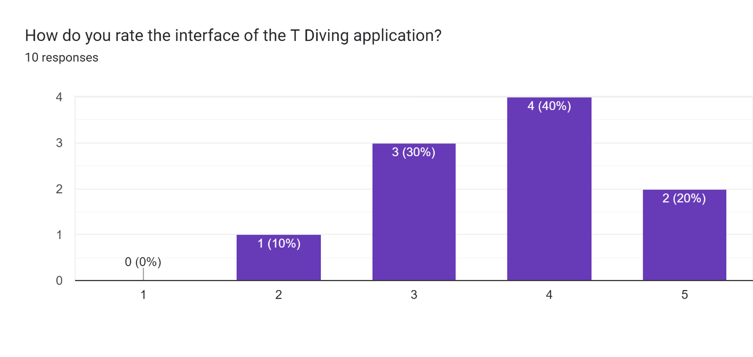

Figure . Question 1

A significant portion, 60% (40% choose 4 and 20% choose 5), rated the prototype as either good or excellent, indicating an overall positive perception of the interface.

**Question 2:**

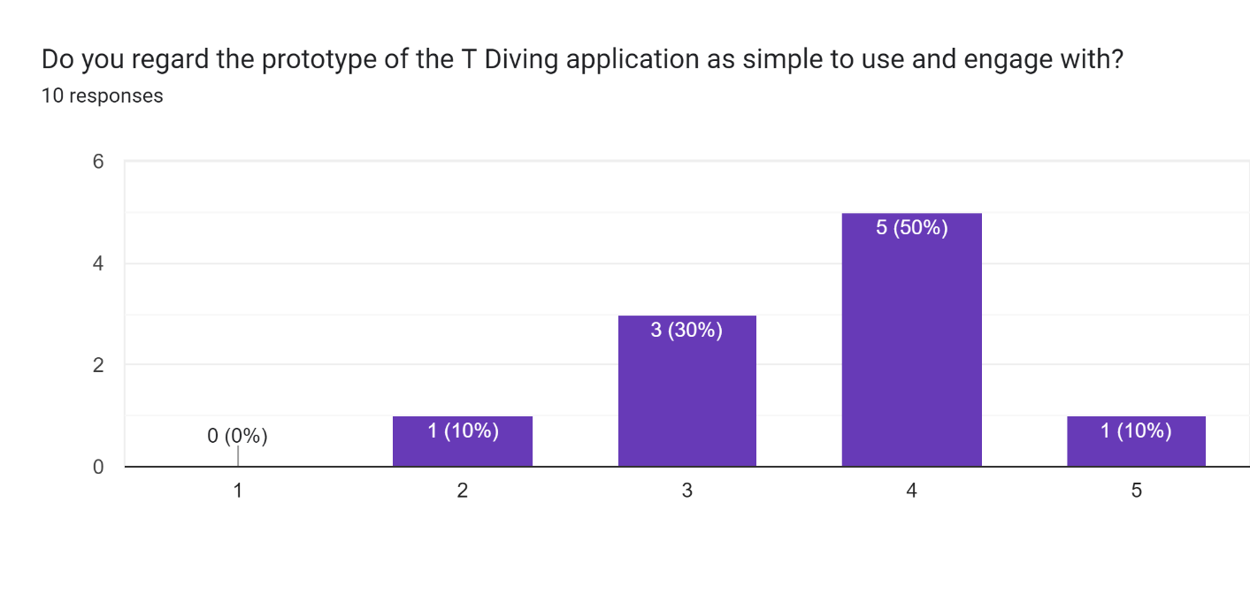

Figure . Question 2

Furthermore, 60% (50% choose 4 and 10% choose 5) of users found the prototype simple to use, supporting the notion that the interface is user-friendly.

**Question 3:**

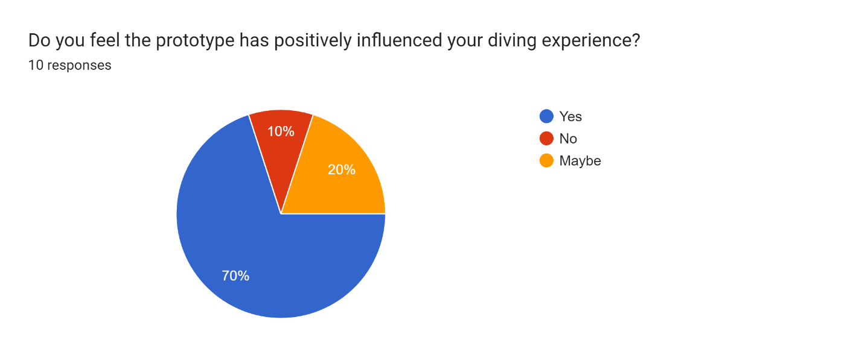

Figure . Question 3

Many respondents, 70%, also believe that the prototype has positively influenced their diving experience.

**Question 4:**

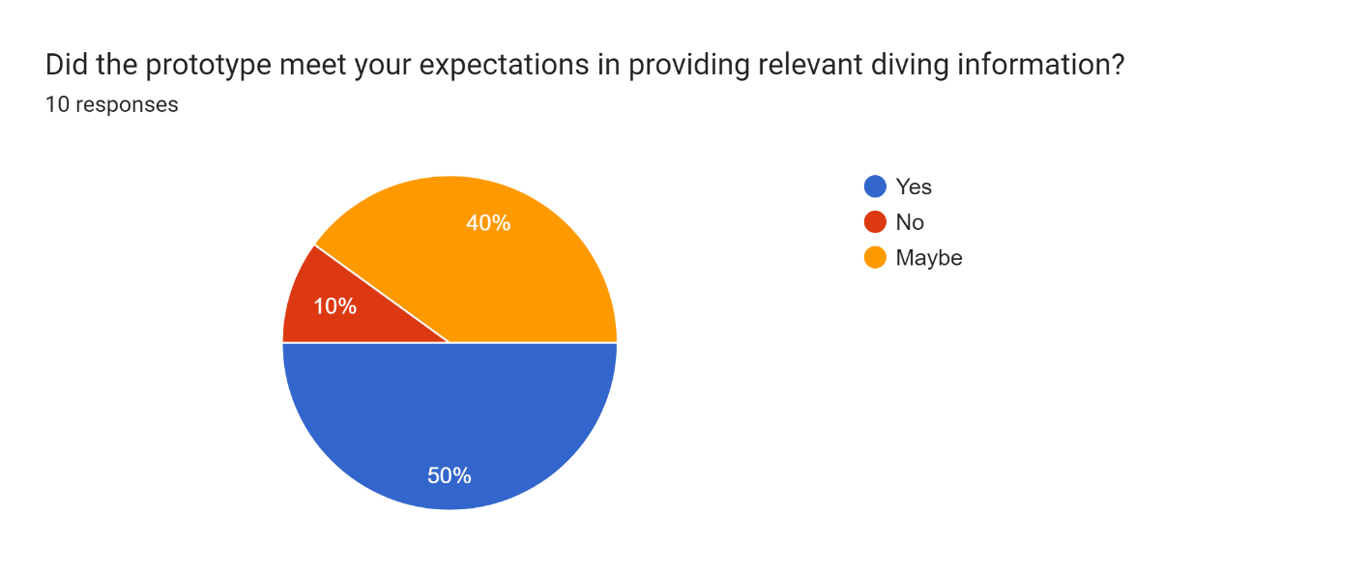

Figure . Question 4

While 50% felt the prototype met their expectations in providing relevant diving information, suggesting room for improvement.

### **Analysis for Hypothesis 2:**

**Question 1:**

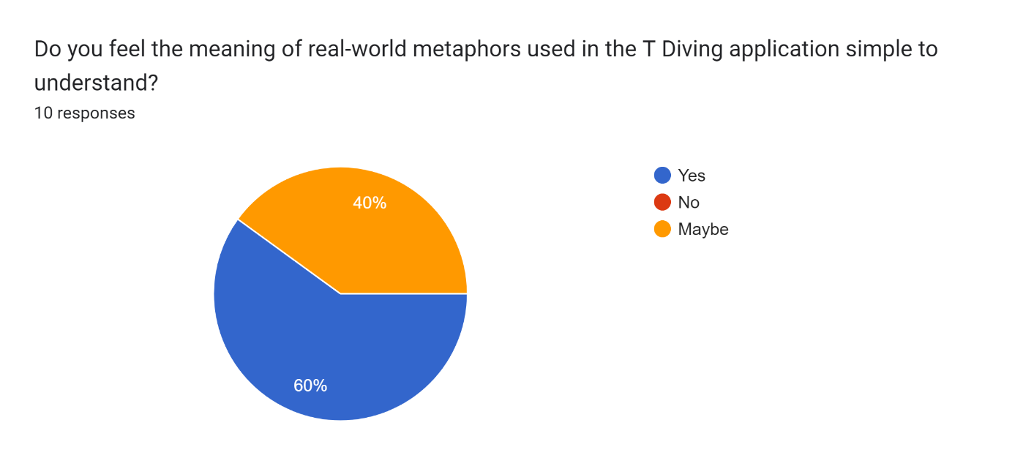

Figure . Question 1

A substantial majority, 60%, affirmed that they find the meaning of real-world metaphors simple to understand, endorsing the intuitive nature of these design elements.

**Question 2:**

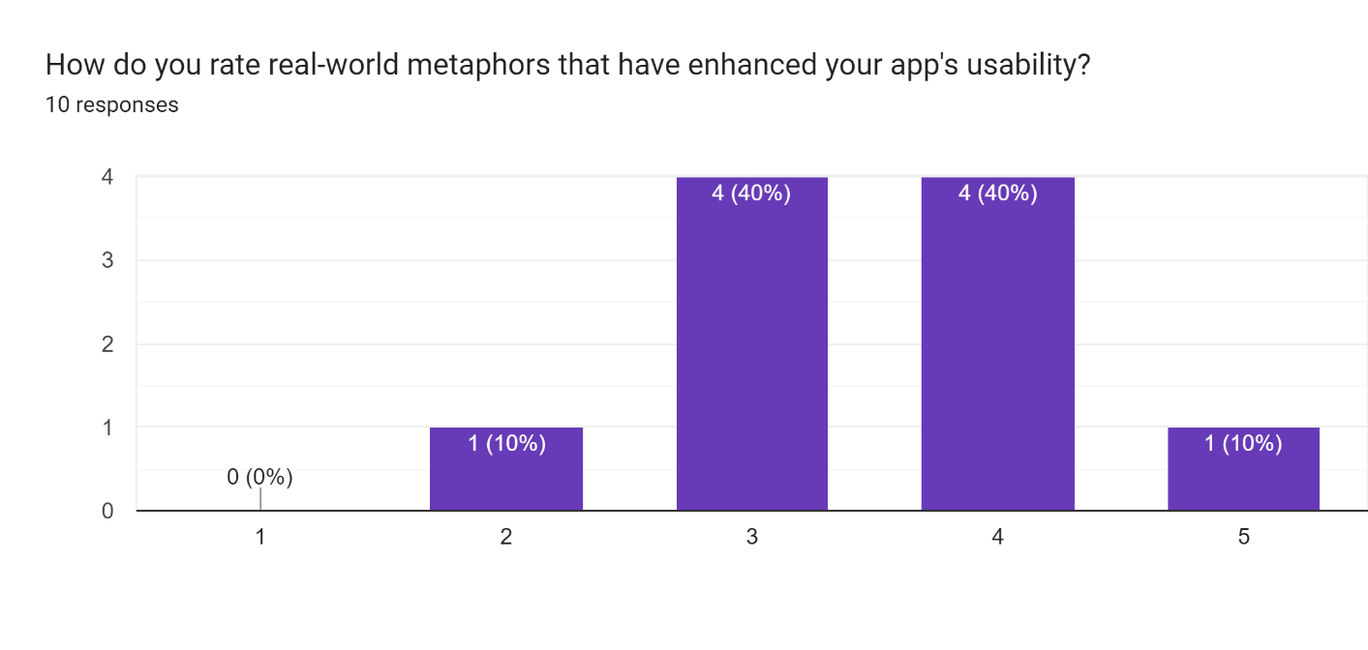

Figure . Question 2

Moreover, 80% of users rated real-world metaphors as good or excellent in enhancing app usability, highlighting the positive impact of these metaphors on the overall user experience.

**Question 3:**

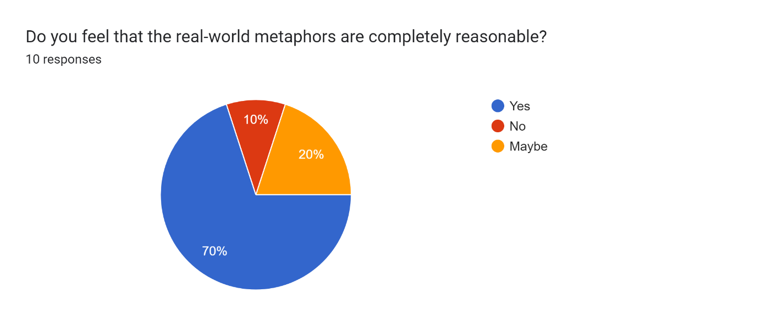

Figure . Question 3

The majority, 70%, perceive the real-world metaphors as completely reasonable, indicating that these design choices resonate well with users.

**Question 4:**

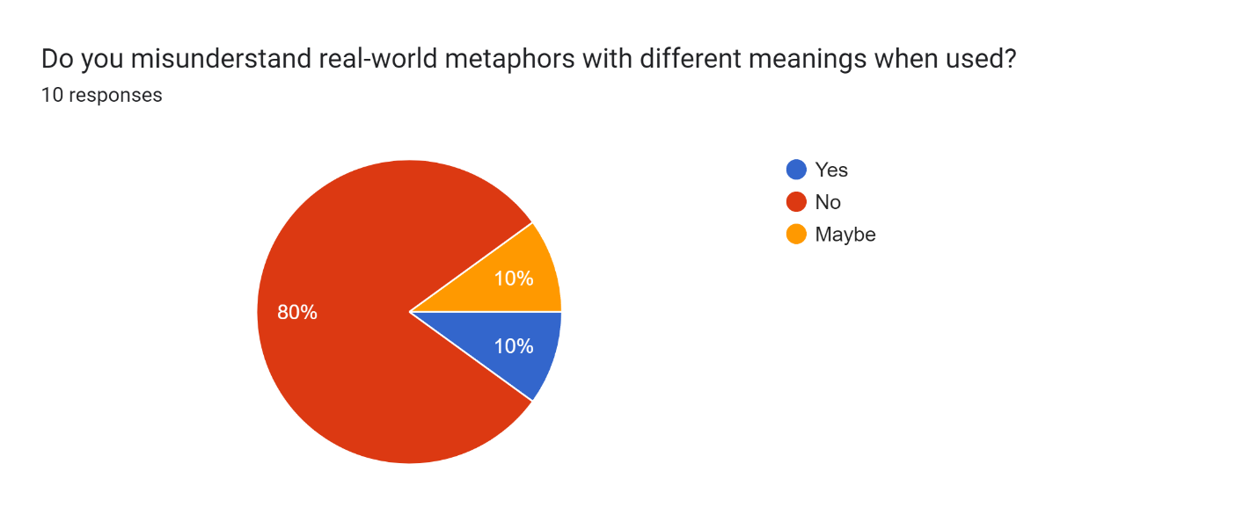

Figure . Question 4

The majority, 70%, perceive the real-world metaphors as completely reasonable, indicating that these design choices resonate well with users.